Swachha Bharat Pakhawra-2018
16 December – 31 December
ICAR-Central Inland Fisheries Research Institute, Barrackpore, Kolkata

Institute: ICAR-Central Inland Fisheries Research Institute
Day: 27.12.18
Activity: Cleaning drive in Raipur village of Birbhum district of West Bengal

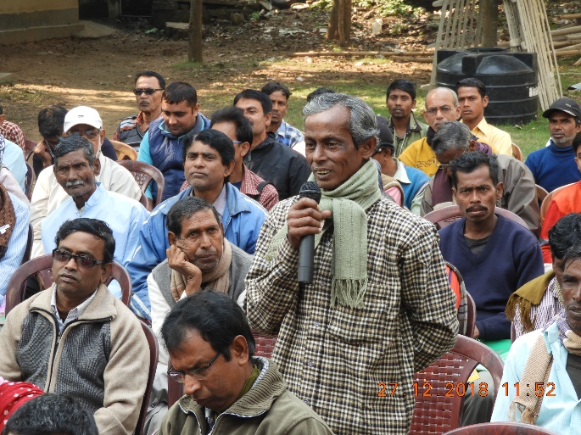
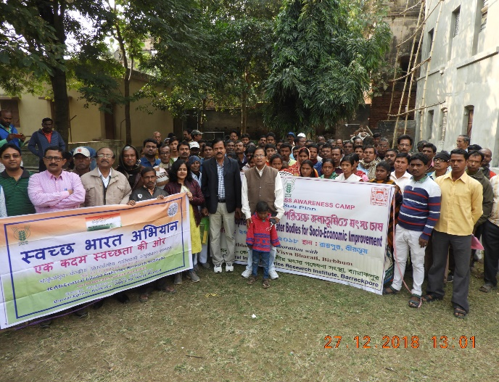
On 27.12.18, ICAR-CIFRI conducted a cleanliness drive at Raipur village of Birbhum district of West Bengal in collaboration with Rathindra KVK, Visva Bharati, Shantiniketan under the Tribal Sub-Plan of the institute. The tribal fishers and the local people actively participated in the drive. A Mass awareness camp on “Fisheries Development in Derelict waterbodies for Socio-economic improvement” was also conducted. Dr. B. K. Das, Director, ICAR-CIFRI advised the fishers to clean the aquatic weeds from the derelict waterbodies and to stock with advanced fingerling for better return. An interactive session was also held between the fishers and the scientists’ panel. More than 120 tribal fishers attended the camp. The women participants were sensitized about the importance of the cleanliness and hygiene in daily life.

Institute: ICAR-Central Inland Fisheries Research Institute
Day: 28.12.18
Activity: Cleaning drive in Gardanmari Village of Burdwan district of West Bengal under TSP programme

On 28.12.18, ICAR-CIFRI organised a mass awareness campaign in the Grdanmari Village of Burdwan district of West Bengal under the Tribal Sub-Plan (TSP) of the institute. More than 100 tribal fishermen of the village gathered in the event. Dr. B. K. Das, Director of the institute addressed the fishermen in his speech and spoke on importance of cleanliness and sanitation in day to day activity of the village. the event was followed by an interaction session with the fishermen who shared their experiences and problems in the session.
